

**American International University- Bangladesh**

**CSC 2209: Object Oriented Programming 1 (JAVA)**

**CO1 Evaluation**

**Project Summary Report**

**Fall 2019-20**

**Group No: 12**

**Project Title: Payroll System**

|  |  |
| --- | --- |
| Student Name | Student Id |
| Alam, Muntasir | **17-34712-2** |
| Hasan, Md. Mahmudul | **17-34711-2** |
| Ahmed, Md. Iftekhar | **17-34731-2** |
|  |  |

**Introduction:**

Managing accounts and maintaining proper records of employee’s time and attendance to prepare payroll manually is a complex and longtime process. We are doing this project for companies to make their time short, task easier and to reduce their cost. This software will calculate employee’s salaries accurately and quickly. This software will provide a complete solution of a company’s payroll needs.

**User Category:**

There are two types of users here. They are:

* Admin
* Employee

**Feature List:**

In this project the “*Admin*” has the following features:

* Login
* Read only own & all employees information
* Add new employees
* Remove existing employees
* Update existing employees
* Logout

In this project the “*Employee*” has the following features:

* Login
* Read only own information
* Logout

**GUI Description:**

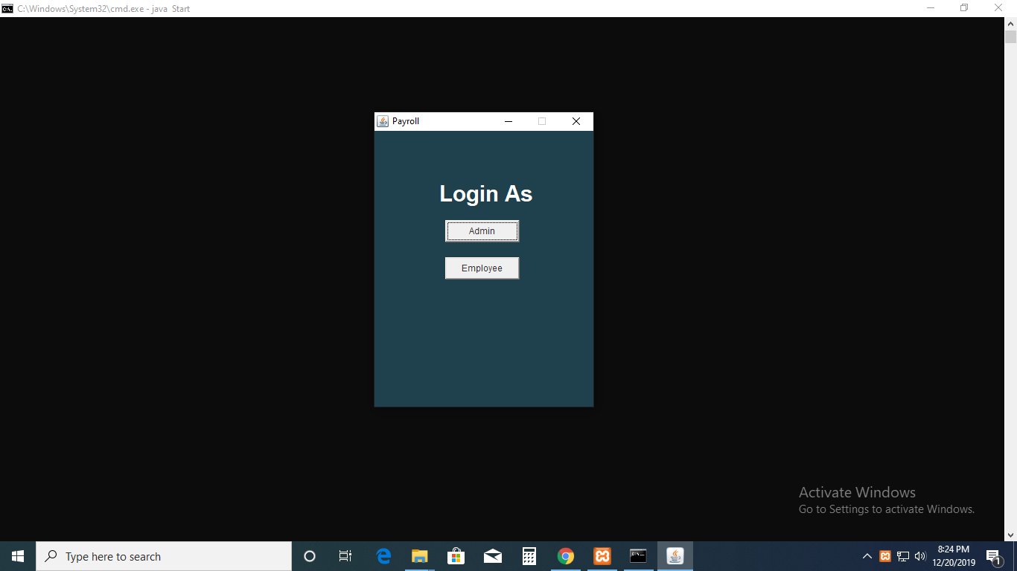

**GUI-1:** This is the first JFrame. From this one can go to admin or employee login Window.

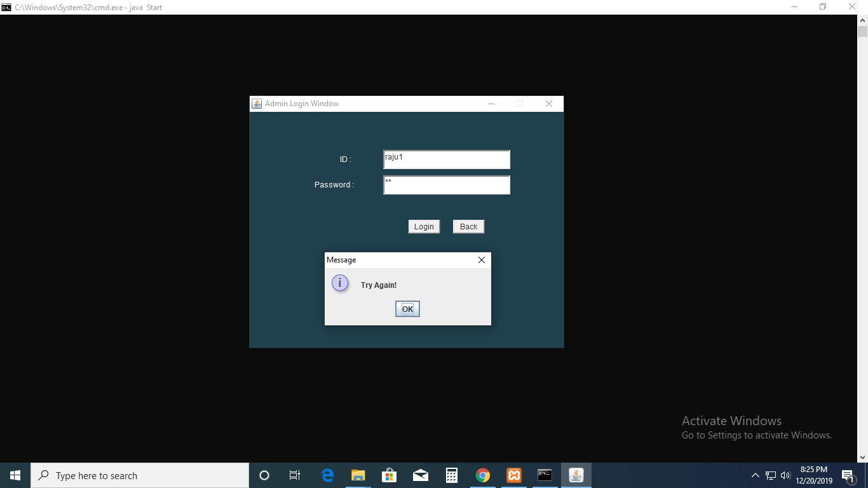

**GUI-2:** This is admin login JFrame. Showing try again in message dialog box because of no matched id or password in database.

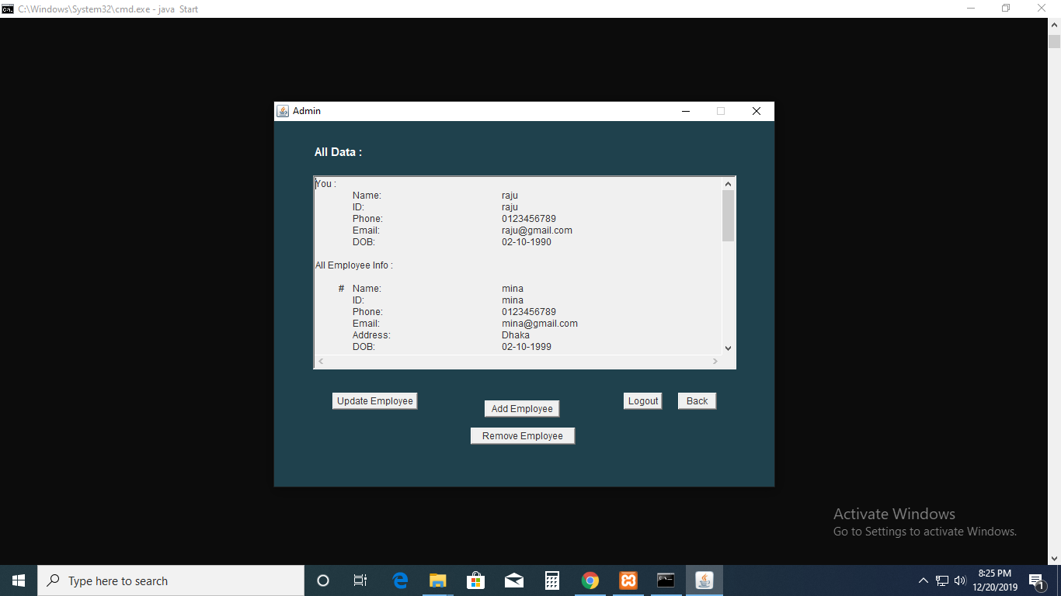

**GUI-3:** One admin successfully logged in. The admin who logged in can see only his/ her information not other admins. But can see all employees each and every information. An admin can update, add and remove any employee.

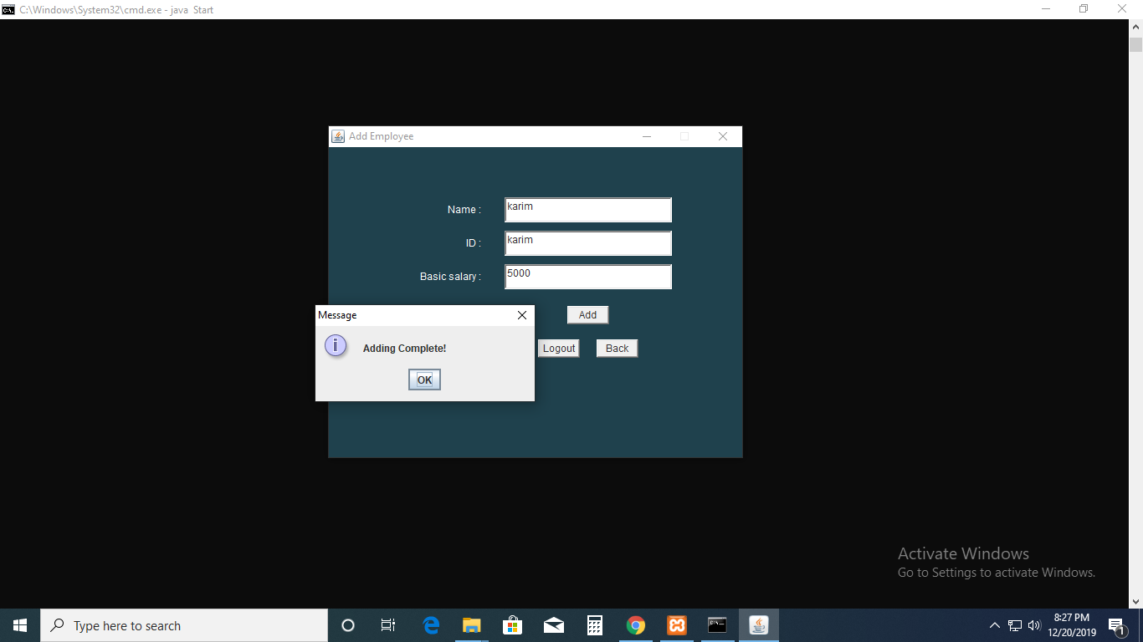

**GUI-4:** An admin successfully added a new employee with automatically system generated password (123) .

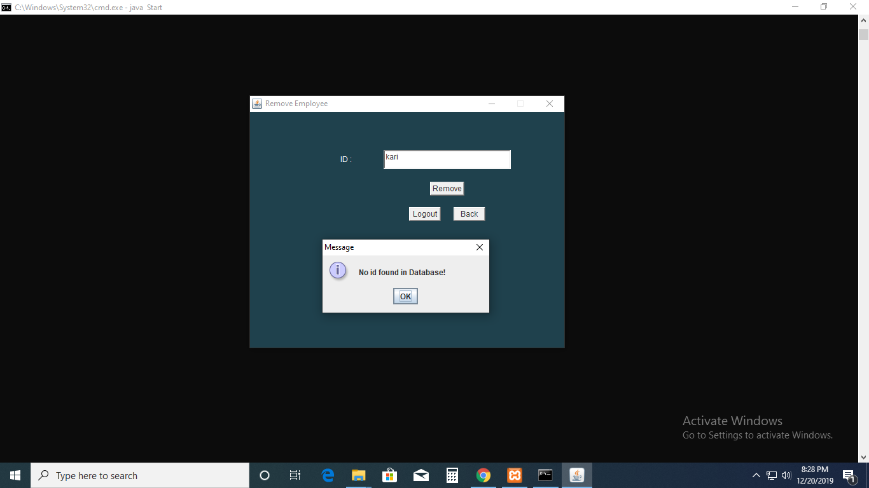

**GUI-5:** An admin could not remove an employee because of empty textField or no matched id in database.

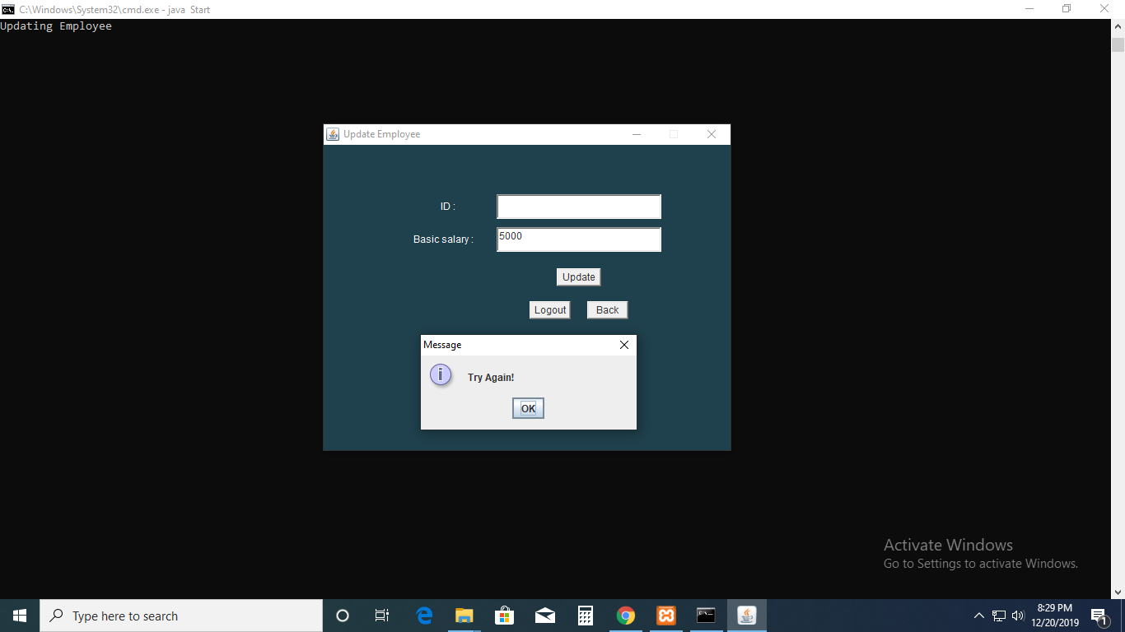

**GUI-6:** An admin could not update an employee because of empty textField or no matched id in database.

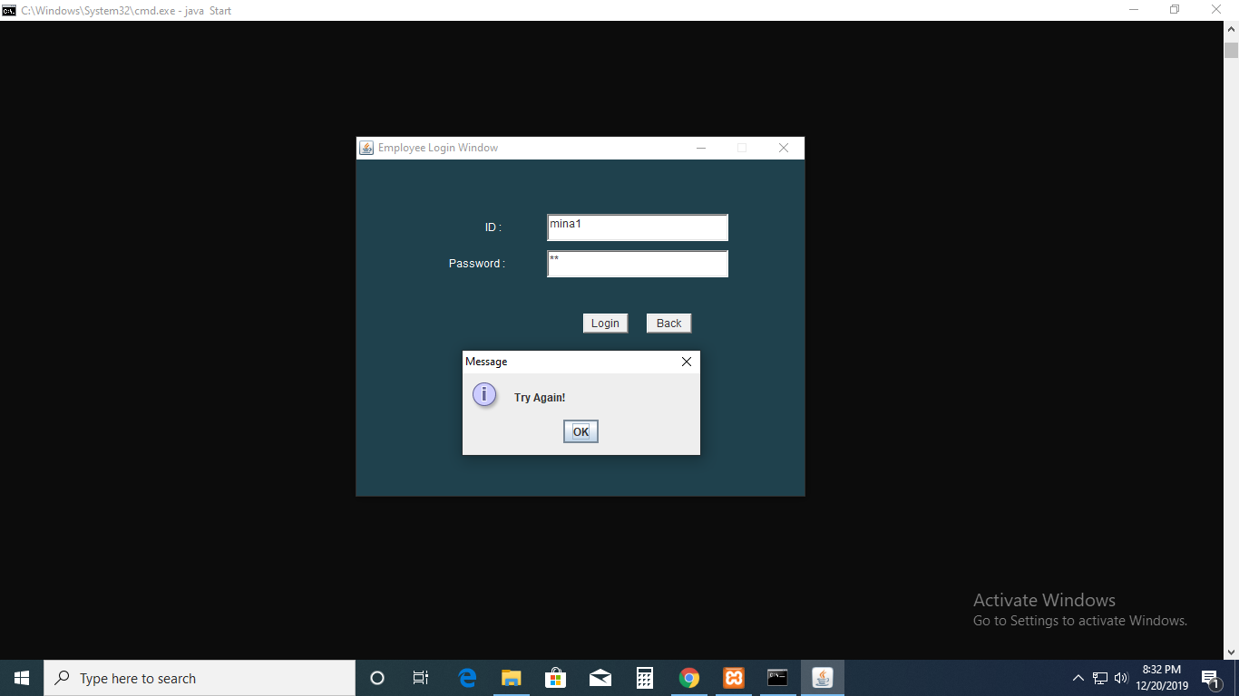

**GUI-7:** This is employee login JFrame. Showing try again in message dialog box because of no matched id or password in database.

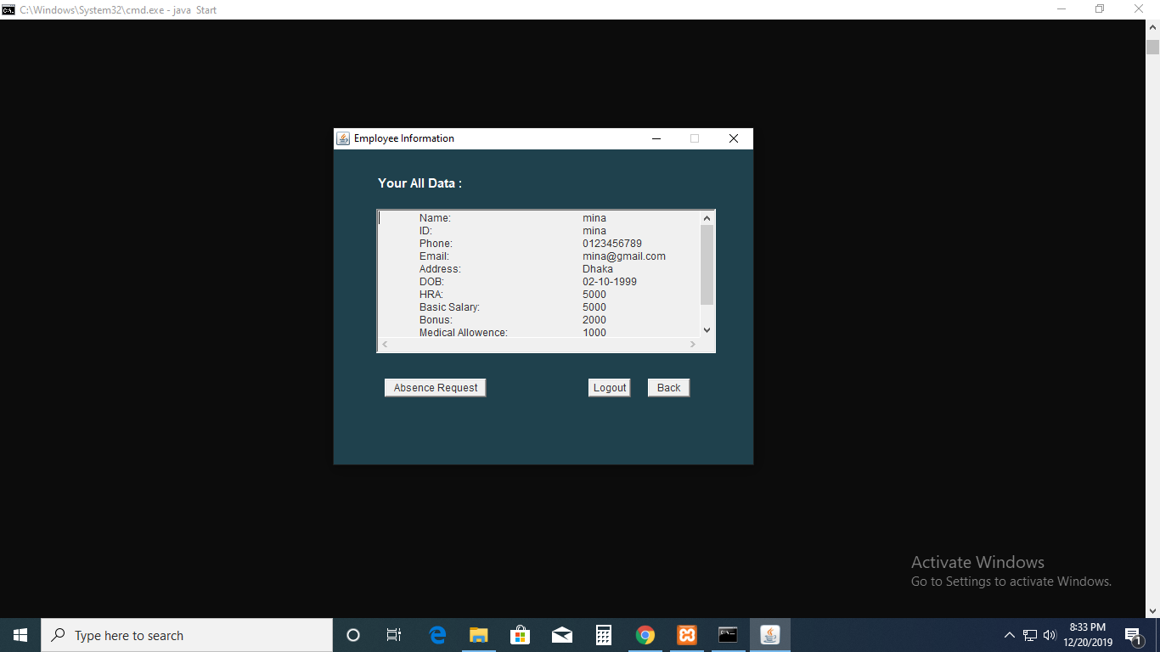

**GUI-8:** One employee successfully logged in. The employee who logged in can see only his/ her information not others (admin or employee).

**Database Table Description:**

Database Name: **payrolldb**

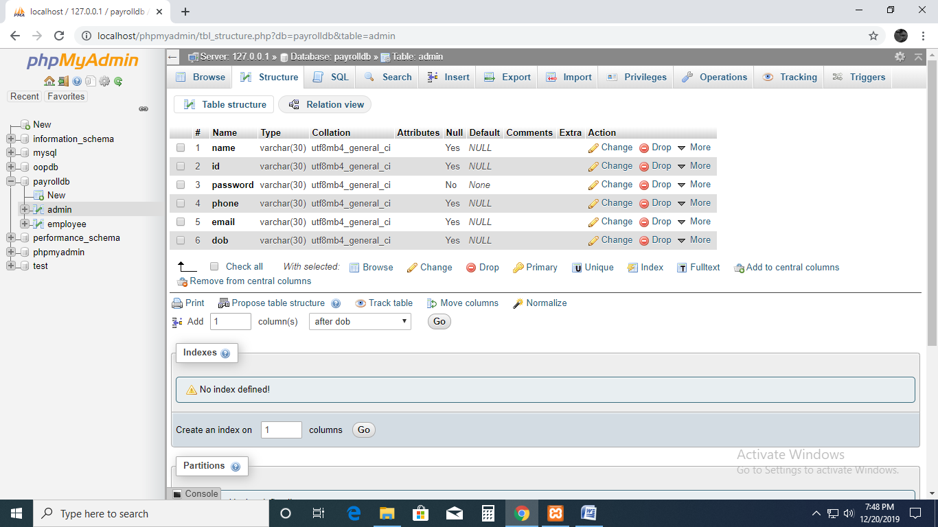

**Fig-1:** admin table structure

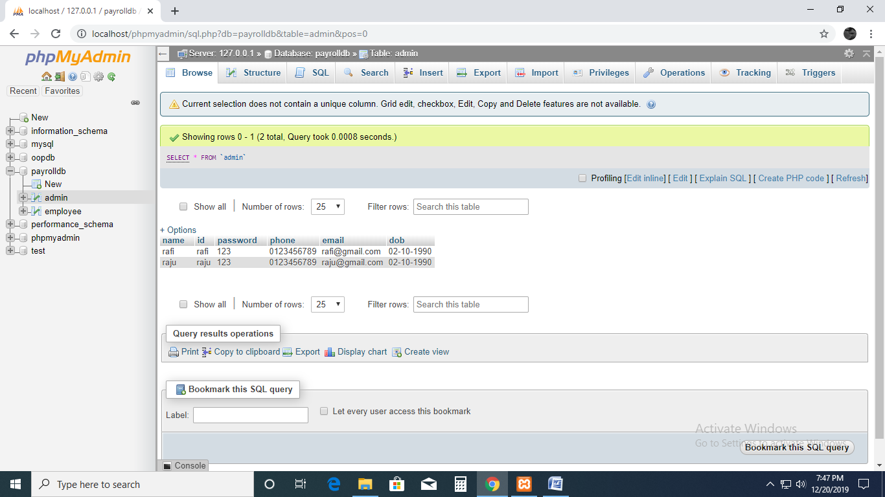

**Fig-2:** admin table values

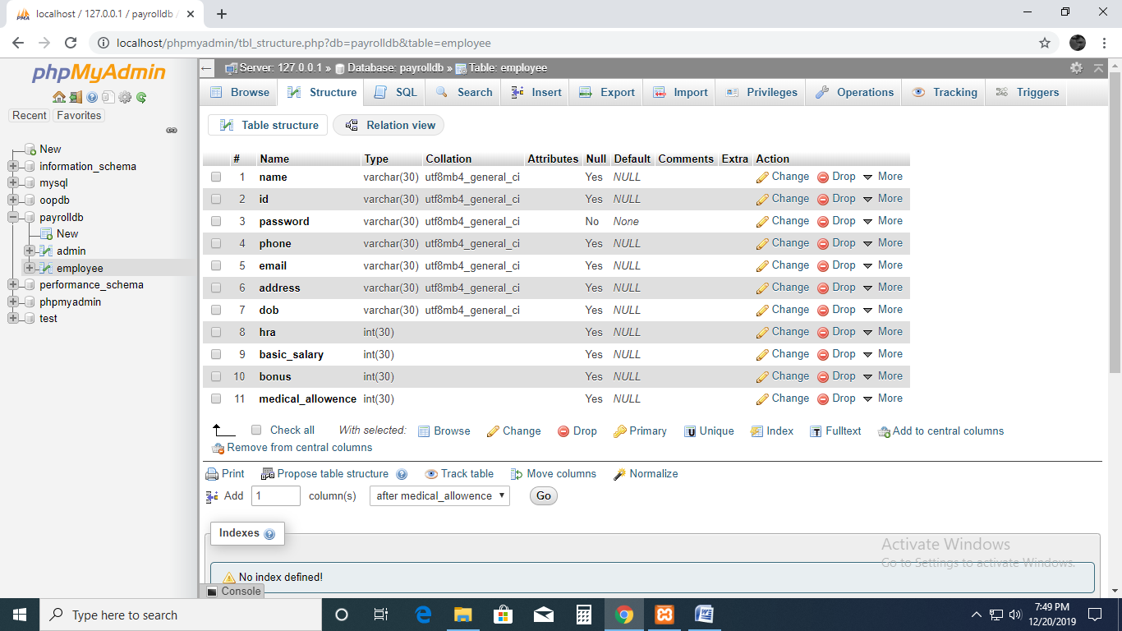

**Fig-3:** employee table structure

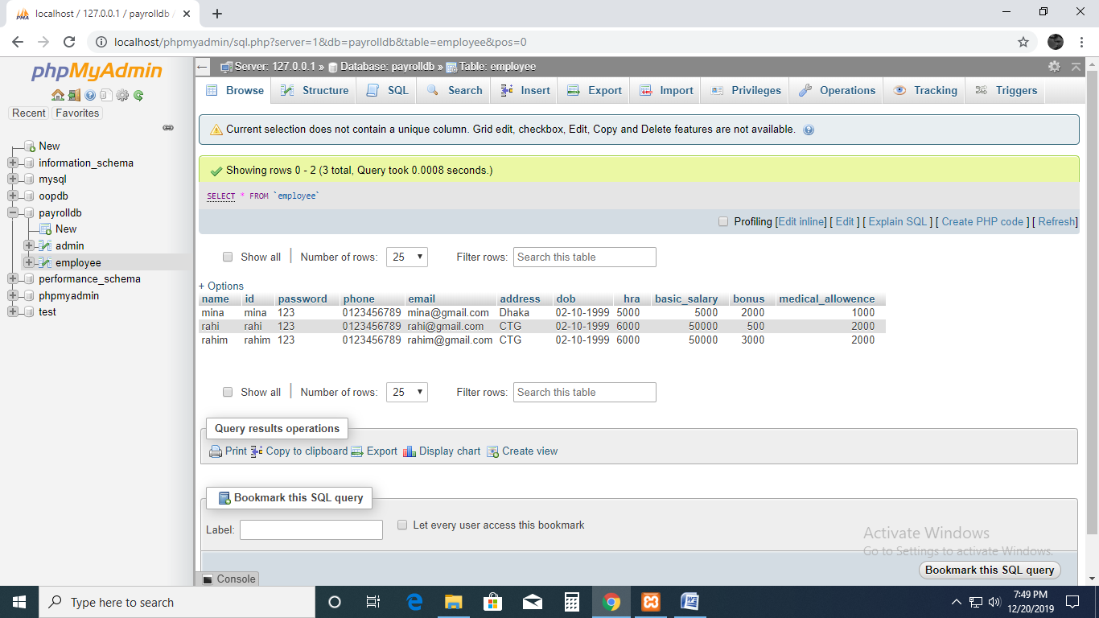

**Fig-4:** employee table value

**Class Diagram:**

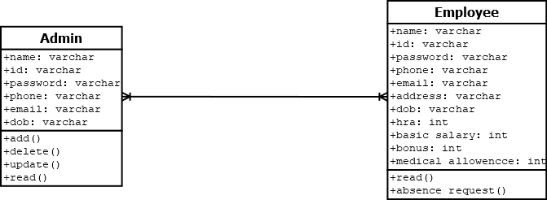

**Tools Used:**

To develop this project we have used the following:

* jdk1.8.0_181
* jre1.8.0_181
* Notepad++
* XAMPP

**OOP and Java Concepts Used:**

* **Encapsulation: All of the class member variables are private.**
* **Inheritance: We have used *JFrame* as super class which is Java’s built-in class.**
* **Abstraction: By Java built-in interface *ActionListener* we have used abstract methods.**
* **Polymorphism:** There are two types of polymorphism in Java: compile-time polymorphism and runtime polymorphism. We have used **Java built-in** class *JFrame* in many classes where method over-loading and method over-riding held.

**Impact of this Project:**

Most companies can use this payroll system to keep thousands data of employees in secure. They can choose this system as it can help them by providing additional data and analysis to make this information more useful to their business. Another impact of payroll software is- a industry can customize detailed reports including each aspect of the company’s payroll. By getting payroll systems that record these additional types of information companies can avoid the need for a separate software package.

**Limitations and Possible Future Improvements:**

Limitations are – we cannot calculate total salary. We cannot store absence and see granting date, absence time. We cannot see employee photos in the software

Possible future improvement- We will update the software. While updating the software we will add calculation feature so that employee can see their total salary. We will add a feature which will store absence granting date, absence duration so that admin and employee can see the absence date and time.